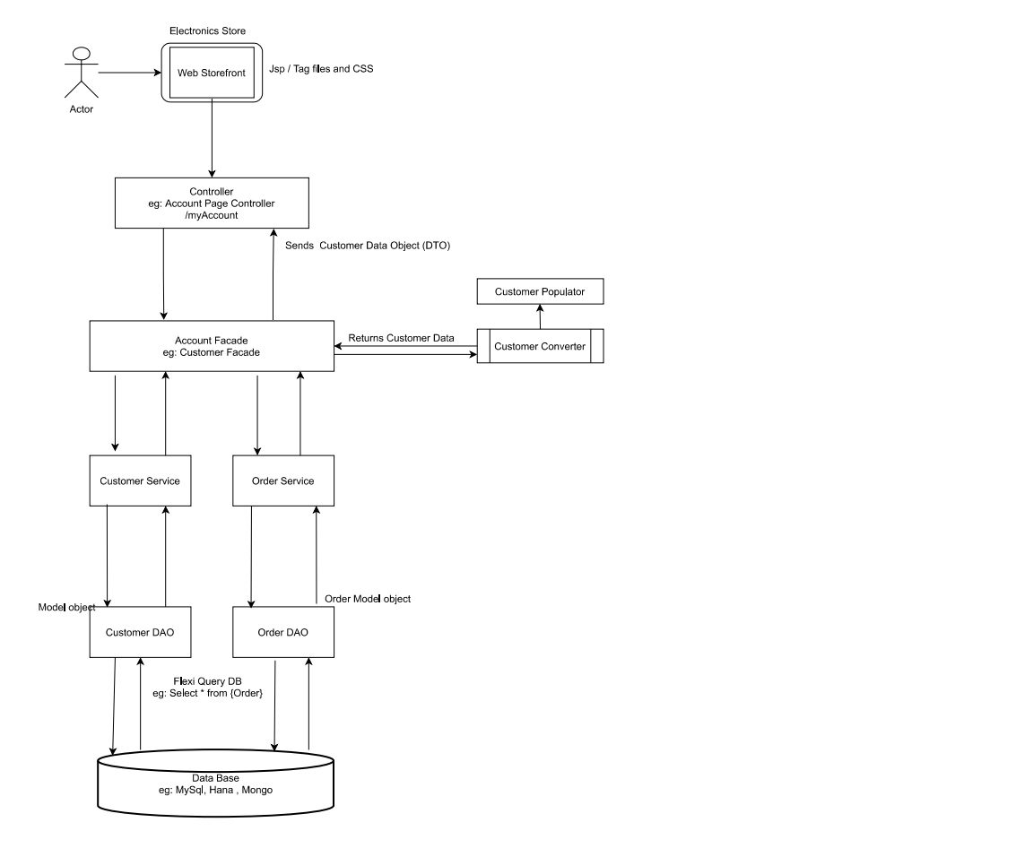

Electronics Store

Web Storefront I

Jsp / Tag files and CSS

Actor

Controller eg: Account Page Controller

/myAccount

Sends Customer Data Object (DTO)

Customer Populator

Returns Customer Data

Account Facade eg: Customer Facade

Customer Converter

Customer Service

Order Service

Order Model object

Model object

Customer DAO

Order DAO

Flexi Query DB eg: Select \* from {Order)

Data Base eg: MySql, Hana , Mongo